1) Demonstrate that you have created IAM policy to shutdown EC2

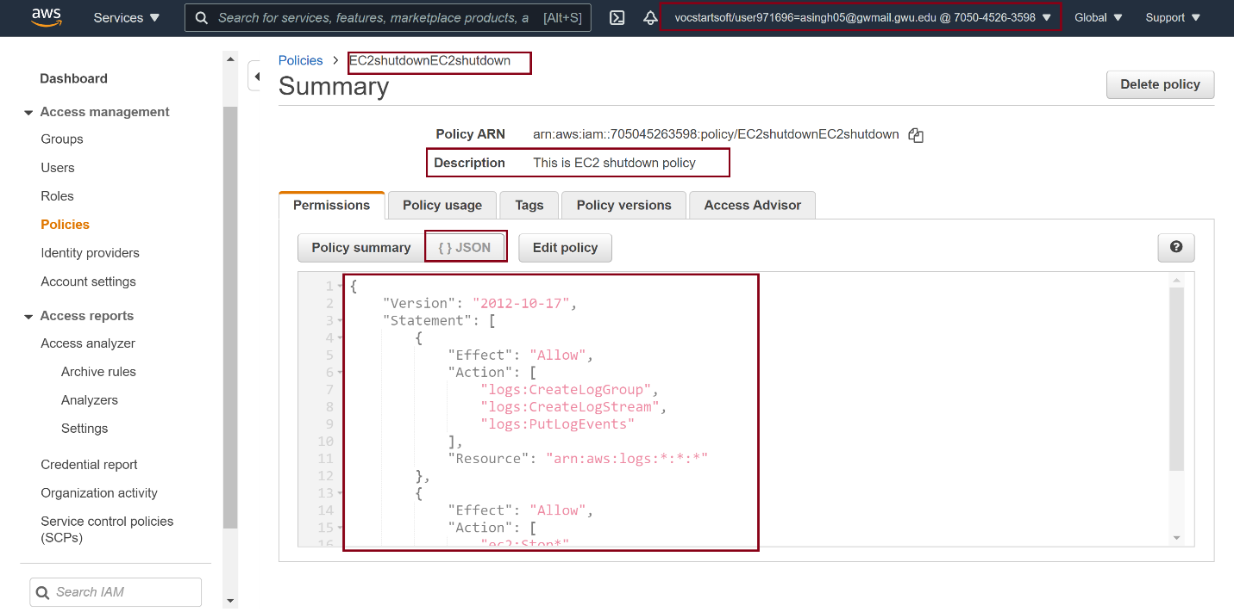

2) Demonstrate that you have created IAM role to shutdown EC2

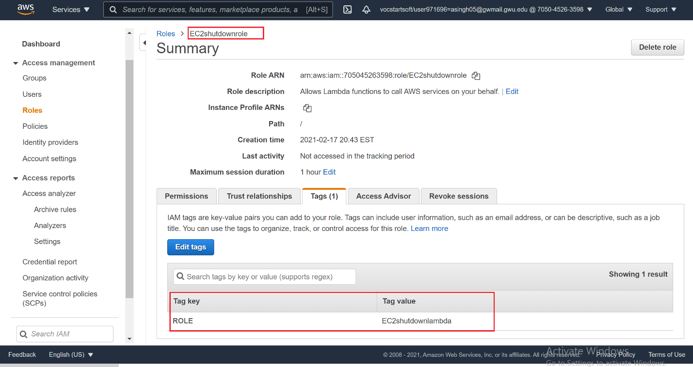

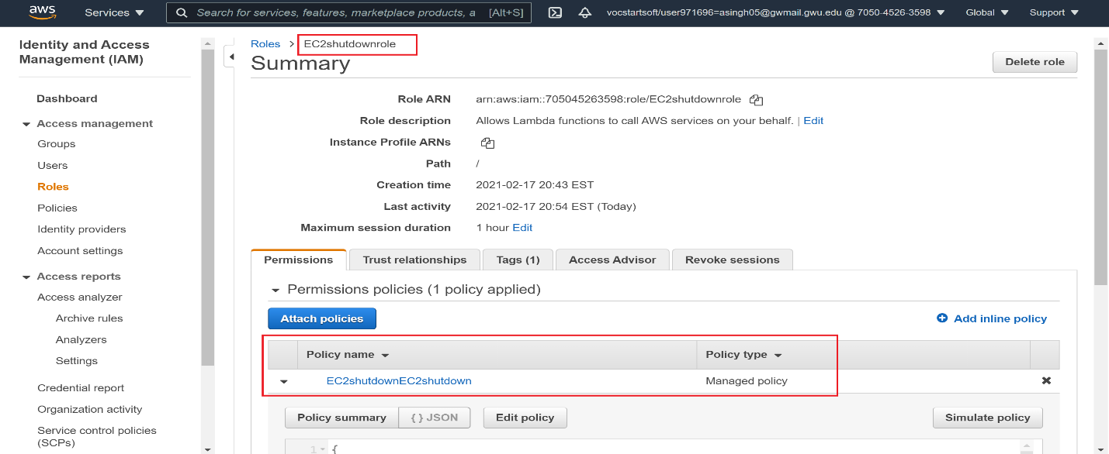

3) Demonstrate that you have created EC2 shutdown Lambda function

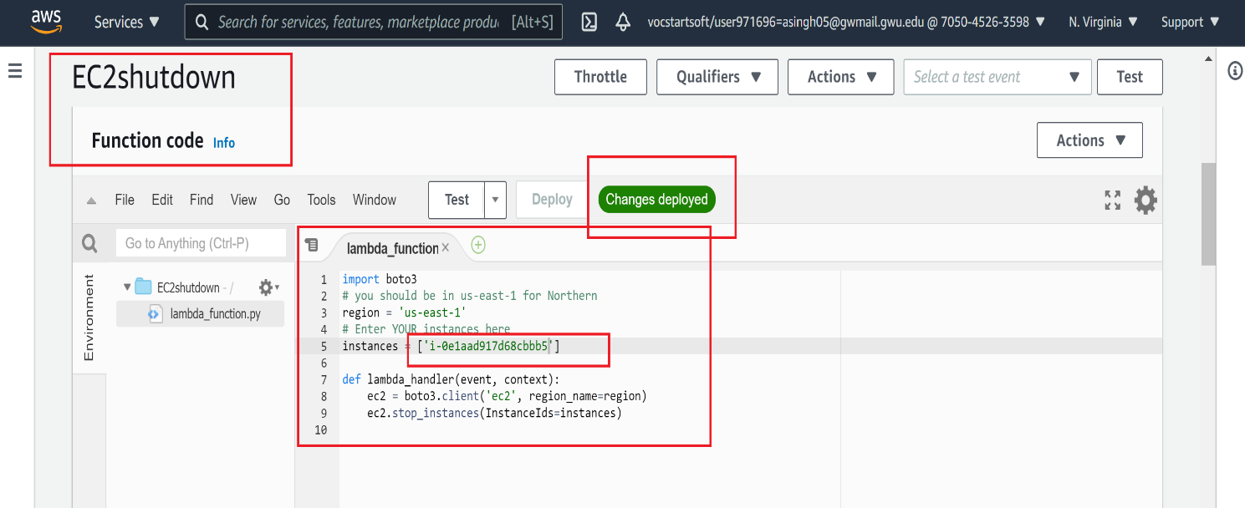

Testing Lambda Function –

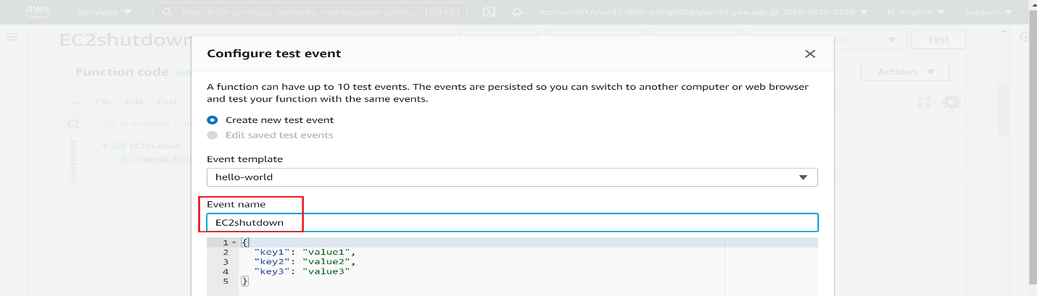

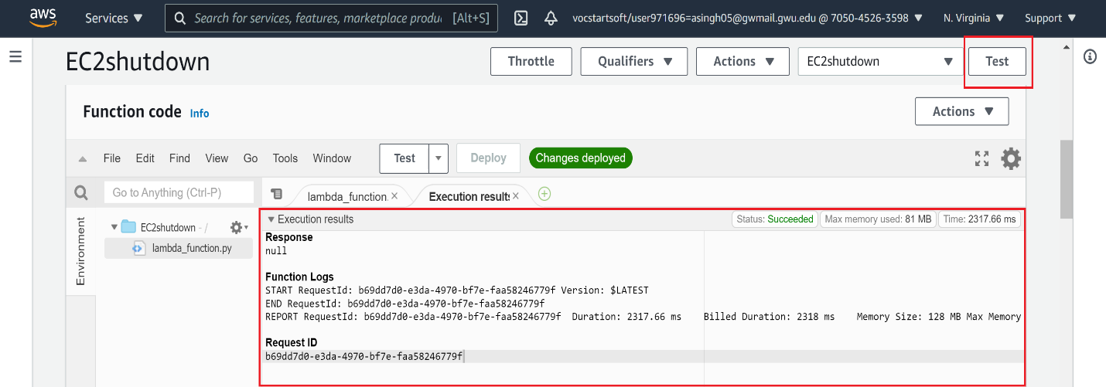

4) Demonstrate that you have created IAM policy to create EC2

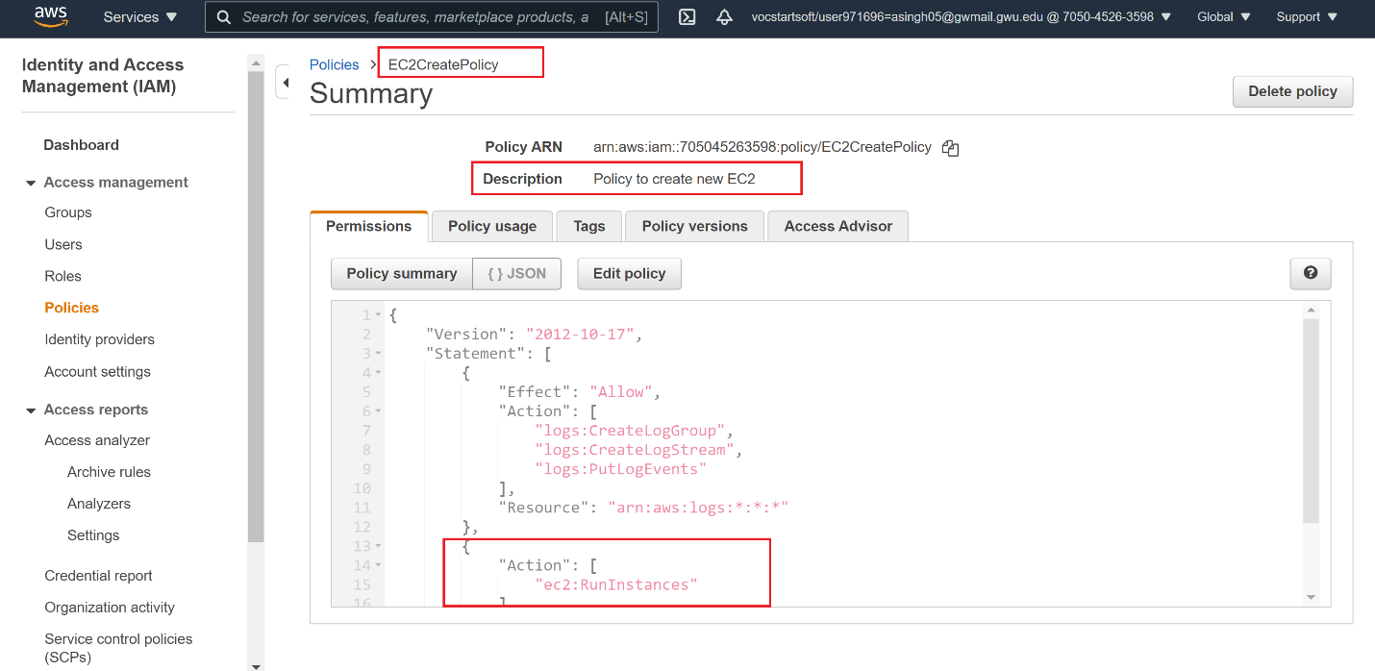

5) Demonstrate that you have created IAM role to create EC2

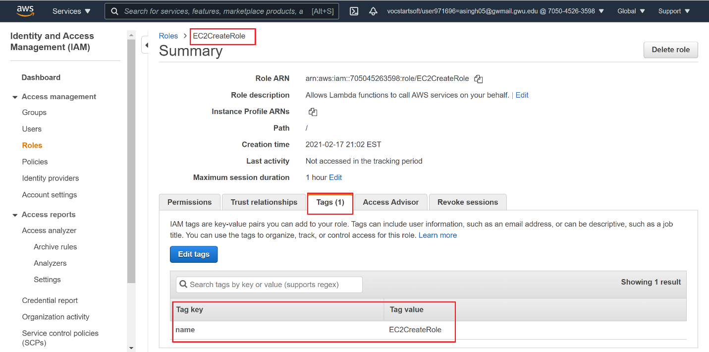

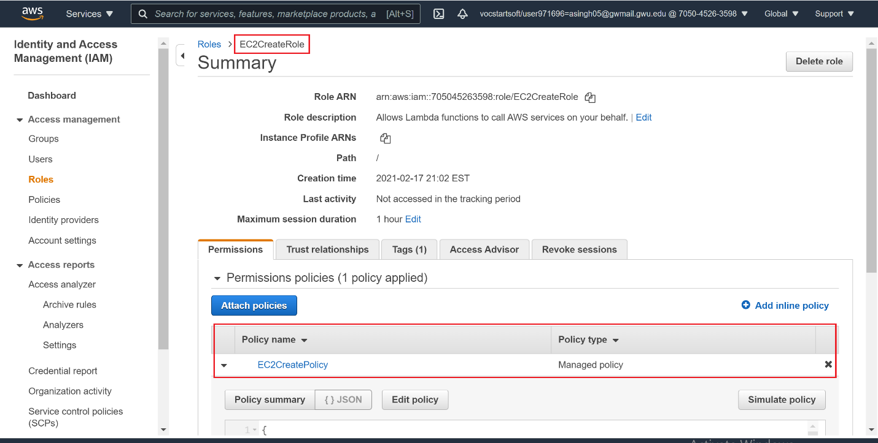

6) Demonstrate that you have created EC2 create Lambda function

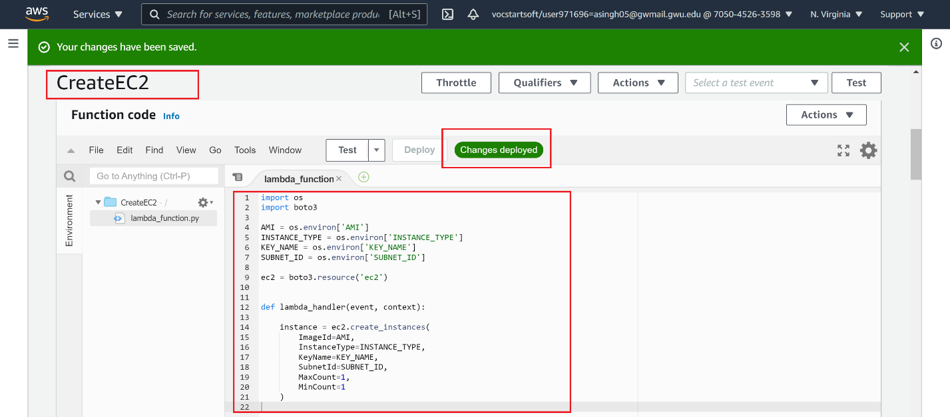

**Testing Lambda Function:**

